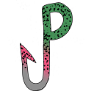

Kill the Phish

# Offered by: Gods of Rods

## Description

Kill the Phish is an extension that detects and warns users of sites that are not real or dangerous. If you were to click a dangerous link, or hover over a link on a page, the extension will tell you whether the site is safe or not.

## Version History

### Version 1.0

Basic extension, warning site, and logo created

## Additional Information

### Language

English